# Apply filters to SQL queries

## Project description

In this project we apply different SQL queries to retrieve data from the database according to the different required conditions. Below we here attempted and retrieved data for 6 different conditions from the database.

## Retrieve after hours failed login attempts

Here we needed to satisfy both conditions so we used the “ and “operator. Both conditions of after hours of office and failed login attempts count.

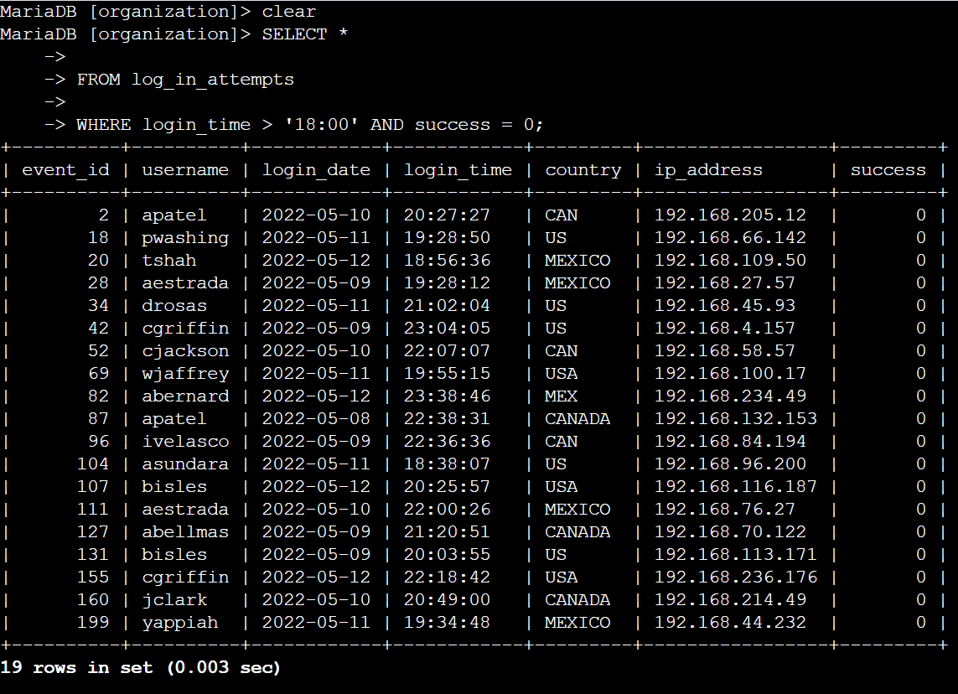

## Retrieve login attempts on specific dates

Here we used the “ or “ operator as we wanted to retrieve data for 2 specific dates.

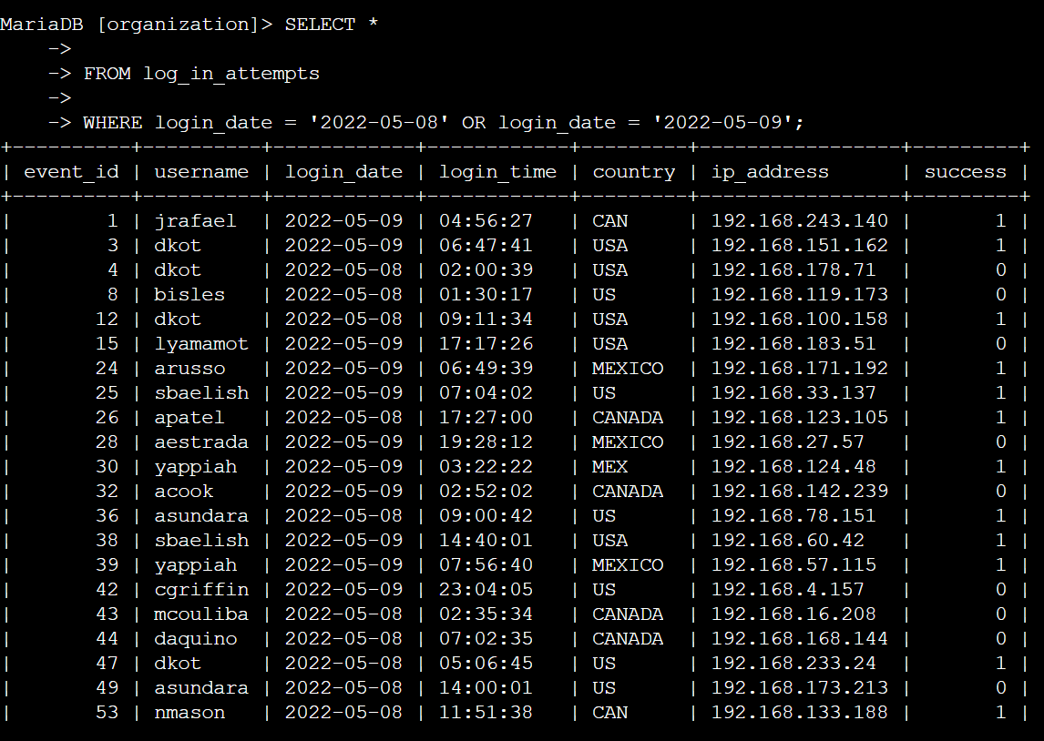

## Retrieve login attempts outside of Mexico

Here we used the “not” operator as we didn't wanted to include country “Mexico” but in the database mexico is given as “Mexico” and also just with initials “MEX” so we used “LIKE” for pattern and used “ %” for wildcard after “MEX”.

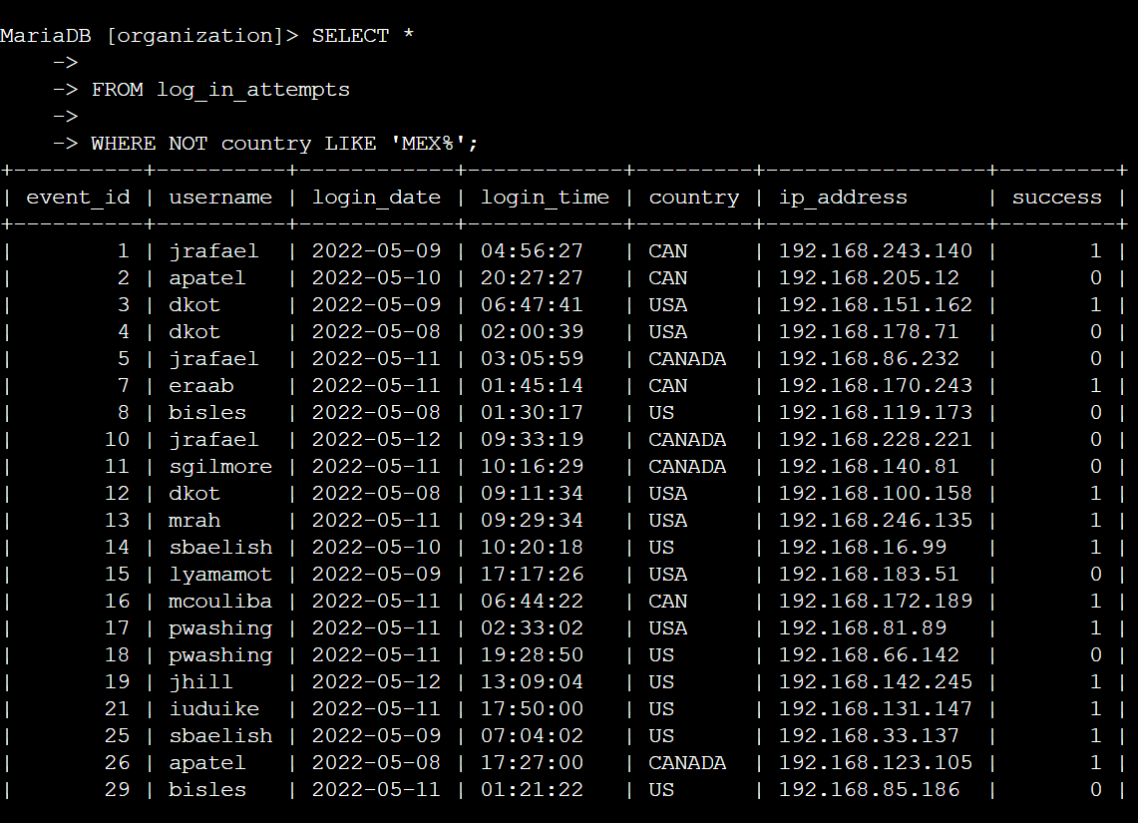

## Retrieve employees in Marketing

Here we used the “ and “ operator to satisfy both the conditions at once. First condition was that the department should be “ marketing” and second the office’s name should start with “East-” so in the second condition we used “LIKE” for pattern matching and “%” for wildcards.

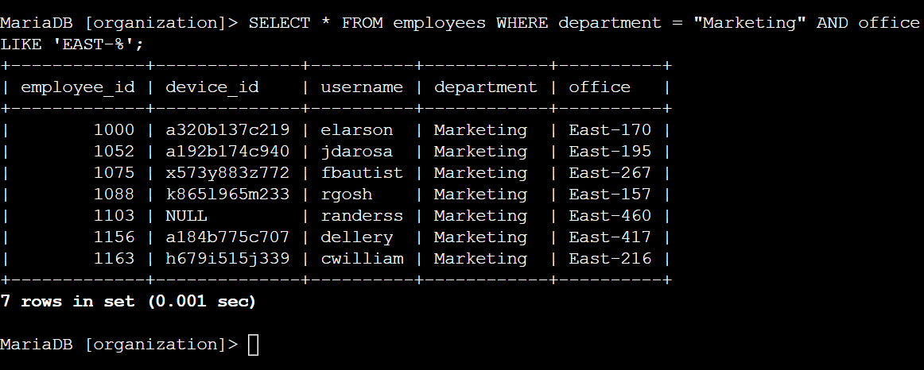

## Retrieve employees in Finance or Sales

Here we used the “ or “ operator as we have to satisfy at least one of the conditions at once. That is here the department should be either a sales or finance department.

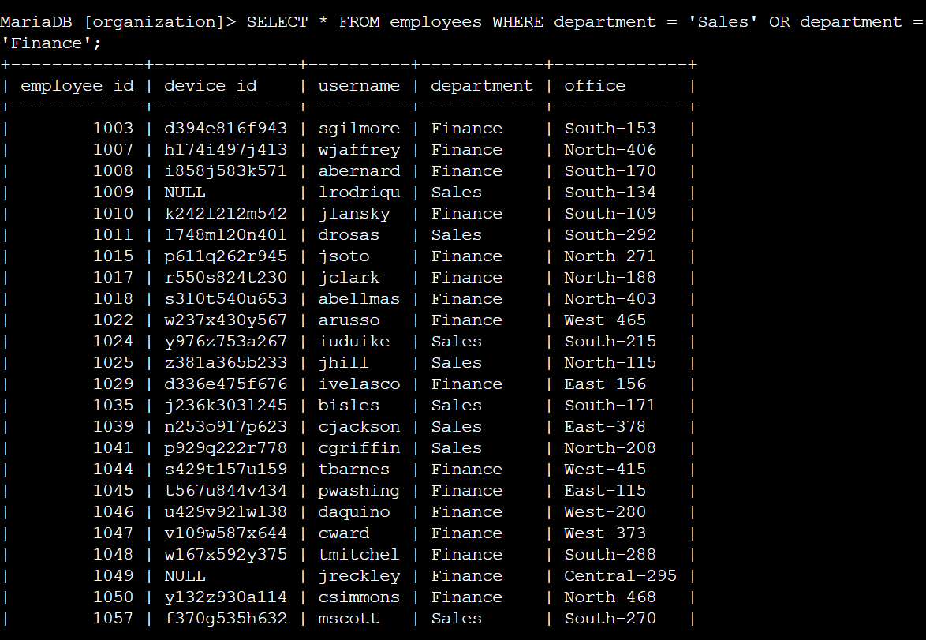

## Retrieve all employees not in IT

Here we use the “NOT” operator as we wanted to find that it must not include the “ Information Technology “ department.

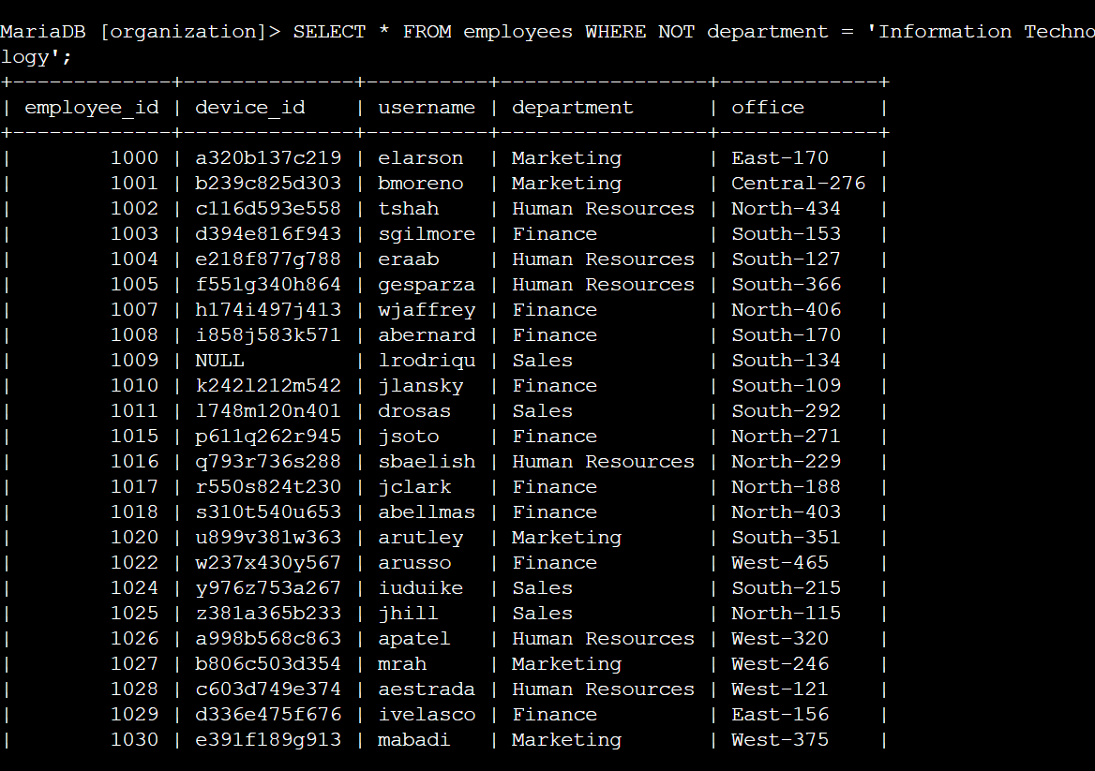

## Summary

We were able to perform each of the tasks and were able to apply different SQL filters and queries to retrieve data in each of the scenarios from different databases.